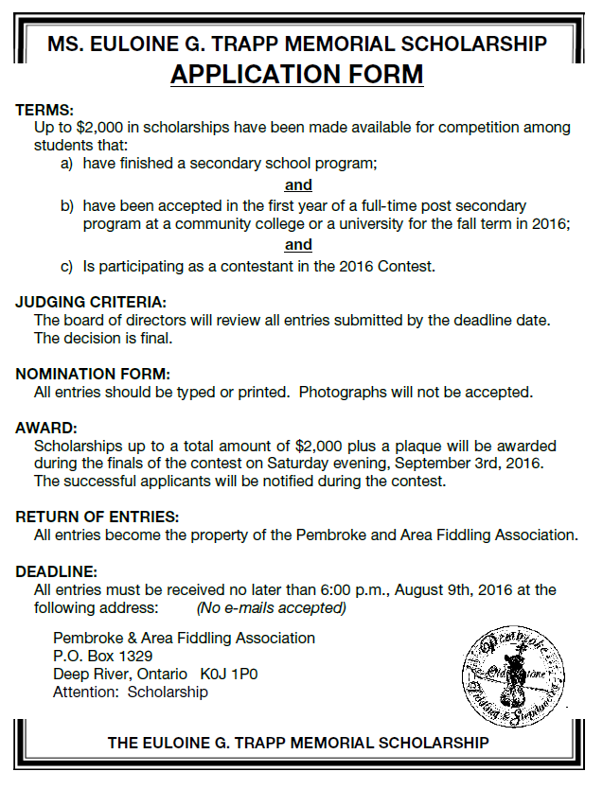
Name:
Address:
Telephone No.:
E-Mail:
Date of Birth:

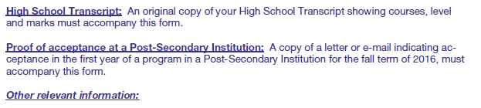
- In which categories are you competing in the 2016 Contest?

- In what year did you first compete in the Pembroke Contest? __________________________

- In what year did you last compete in the Pembroke Contest? __________________________

- In what other contests have you competed in the last 5 years other than the Pembroke Contest?
- Why do you feel that you deserve The Euloine G. Tapp Memorial Scholarship?
(In 100 words or less).

SIGNED: _____________________________________ DATED: _________________________________ (Use another page, if necessary.)

